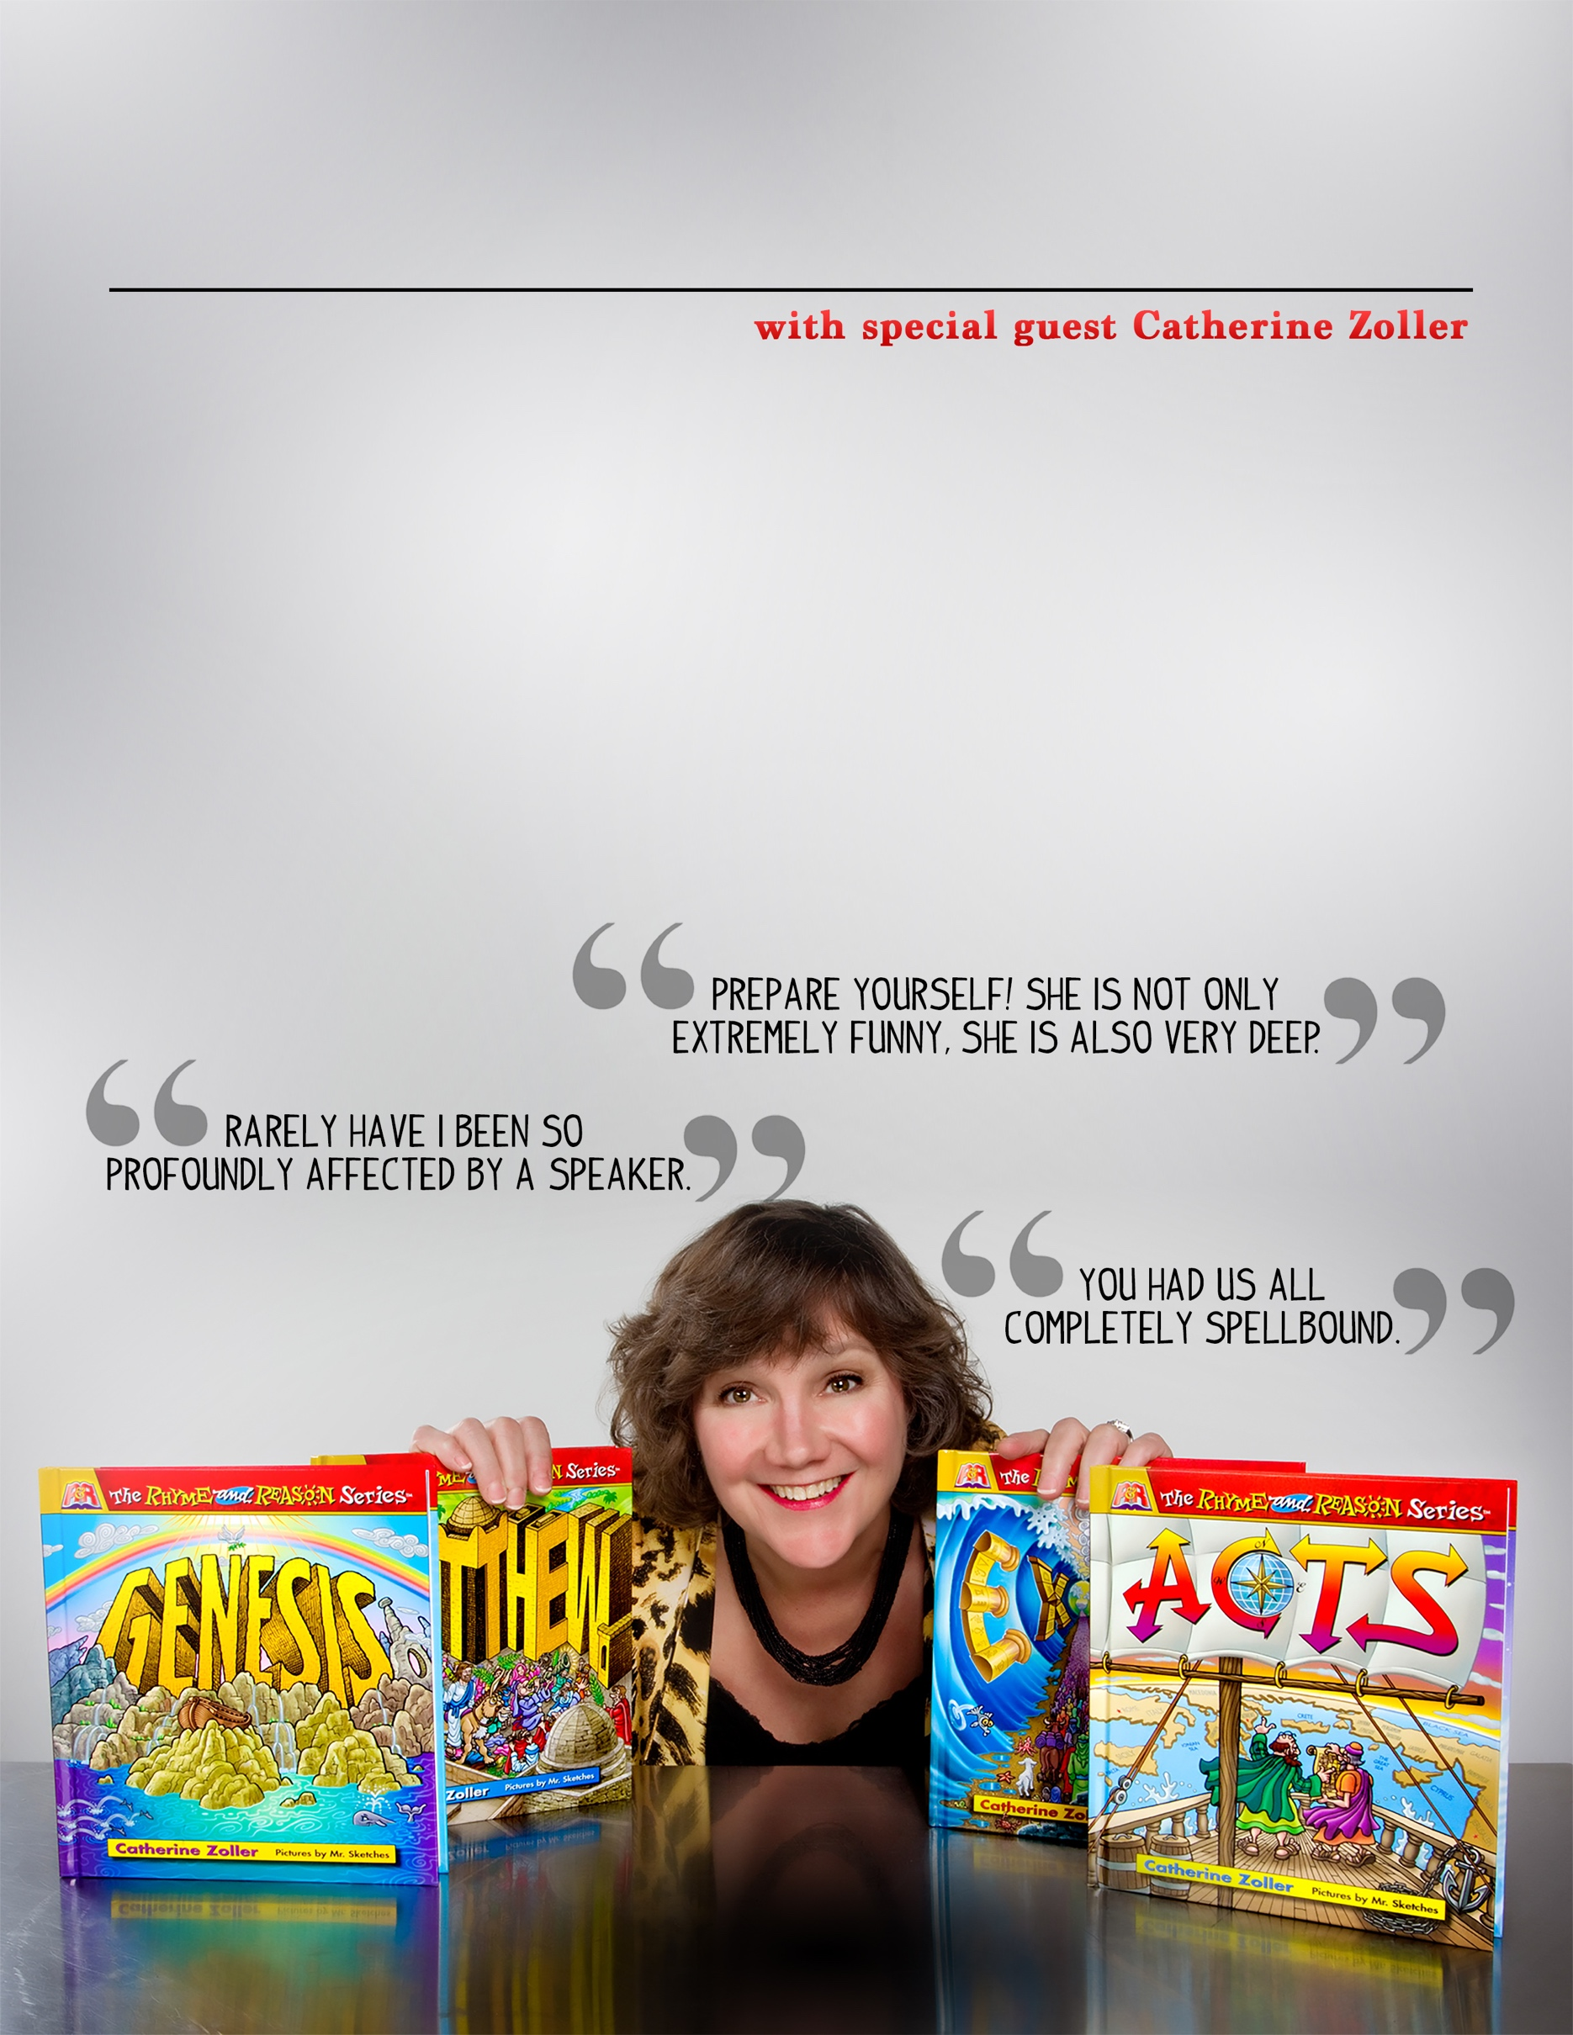

**LOGO HERE**

More info about the event can go here.

Website or phone number to contact goes here.

Catherine Zoller is an international speaker and author of the Rhyme & Reason Children’s Book Series. From her personal story as a teenage runaway and juvenile delinquent to a miraculous encounter with God to enduring the loss of her son, Catherine’s testimony will deeply impact you even as her natural humor keeps you laughing.

Heralded as “Dr. Seuss meets the Bible,” Catherine’s Rhyme & Reason series has entertained children worldwide as her rhyming schemes, delightfully paired with humorous illustrations, bring Bible stories to life.

YOUR EVENT NAME HERE